

**240 S. Illinois Route 59, Bartlett, Illinois 60103**

**Hanover Township Senior Center**

**Veterans Hall**

**Meeting of the Senior Citizens Services Committee**

***Monday, March 8, 2021***

**1:00 PM**

**A G E N D A**

1. Call to Order - Roll Call
2. Pledge of Allegiance
3. Public Comments
4. Reports

A. Chairperson’s Report

B. Treasurer’s Report *(page 2)*

C. Trustee Liaison’s Report

D. Director’s Report *(page 6)*

1. Unfinished Business
   1. Paczki Day Fundraiser Recap *(page 9)*
2. New Business
   1. Regular Meeting Minutes of February 8, 2021 *(page 10)*
   2. Recognition of Outstanding Service for Staff
   3. Discussion of Potential Spring Fundraisers
   4. Presentation of In-Home Care Pilot Program *(no handout)*
3. Other Business
4. Adjournment

*Next Meeting scheduled for Monday, April 12, 2021*

*in Veterans Hall at the Senior Center*

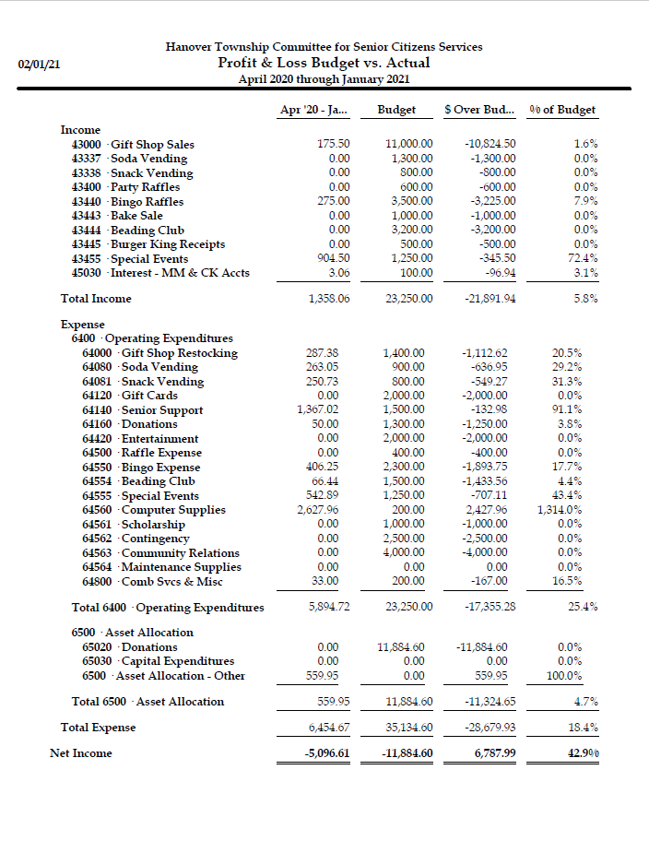

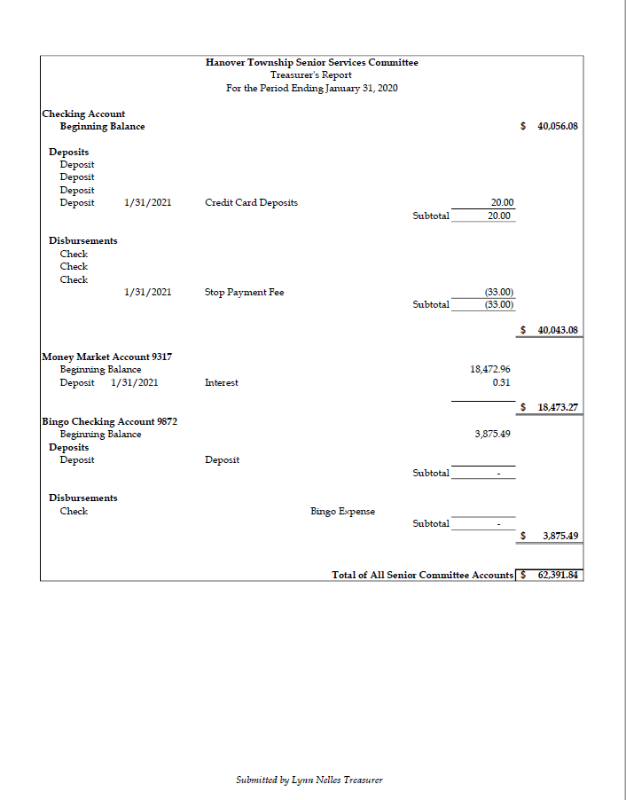

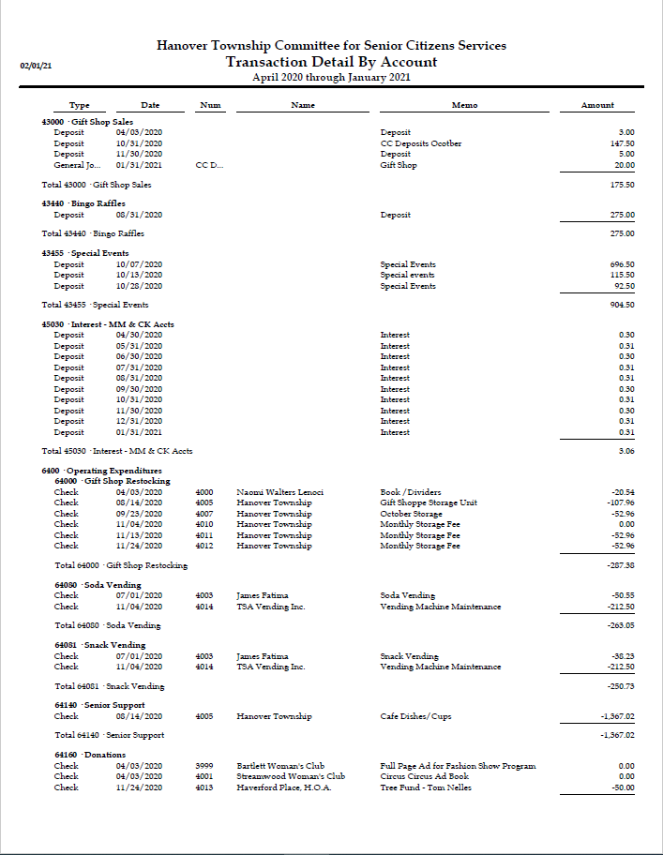

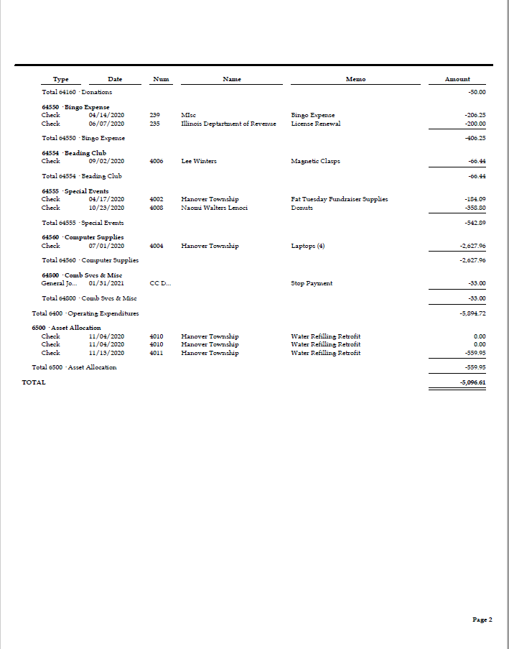



Director’s Report for February 2021

Department of Aging Services

It is hard to believe that the year is over and we are now in 2021. I wish you all a prosperous and healthy year. I know the past year was incredibly difficult with the impact of COVID-19. While it was an incredibly difficult year, I am so proud of our staff and volunteers for the support and services provided. There seem to be some glimmer on the horizon as vaccine distribtion has begun and our region enters phase four while I write this.

The biggest news of January is that the Aging Services team completed a program audit with staff at AgeOptions. The virtual audit was competed January 26 – 29. AgeOptions provides significant fundign for the nutrition services, transportation, Senior Center, and some social services activities. They will generate a report and share with us within thirty day. I will follow up with any findings or feedback from the audit.

As a result of our region moving to phase four, our team resumed in-person activities on January 25. We hope to see you in-person while maintaining safe social distance and other safety protocol. Our transportation service will also be moving to transport two riders at a time given the new guidance. The Illinois Department on Aging impacts when in-person dining can resume; at this time, we do not expect to open the café for some time. We will share additional updates as they become available. The Pool room will be available Tuesdays and Wednesdays by appointment. We will also have weekly in-person movies, art classes, computer classes, and more in-person. If you have suggestions for virtual or in-person activities, please contact us today!

The AARP program is scheduled to start in the first week of February. We began taking appointments for this program on Monday, January 25. At this time, all slots are filled and we are operating a waiting list. We anticiated a high interest in the program due to a short program year in 2020 and fewer available sites this year. Many other local sites report being at capcacity also. Due to guidelines by AARP, the tax appointments will be in two phases; appointment one will review documents and scan them in while appointment two will be to review and sign. We appreciate everyone’s patience as we work with a new location, new safety guidelines, and a new process for completing the returns.

There has been a lot of news recently on the COVID-19 vaccine. At this time, vaccinations are available to people in phase 1A and 1B. All adults in Illinois who are over the age of 65 are eligible under phase 1B. That said, there continues to be a severely limited supply of vaccine stock. We have heard from many people their frustration in navigating the online systems or hotline phone number. We understand this is a very stressful time. The Township Office of Community Health can help answer vaccine questions at 630-483-5665. Vaccine distribution is coordinated by the Cook County Public Health Department in our area. Please see the flyer in the packet for more information on vaccination. We will share information on any local vaccine clinics as we learn of them. We suggest reaching out to your physician, local pharmacy, and/or registering with the Cook County Vaccine website at <https://vaccine.cookcountyil.gov/> or calling 833-308-1988.

Don’t forget to sign up for the weekly e-newsletter so we can share timely updates on program changes and follow us on facebook (https://www.facebook.com/HTASIL) . The more people interact with our facebook page, the better visibility we have. Please “like” us! Also, you might notice some changes to the March/April *Club 59*. Many thanks to Florie Sposito for reformatting the sections. Let us know what you think of the new look!

Hot off the presses: I am also pleased to share that the Association of Illinois Senior Centers will award Hanover Township Aging Services with the annual *Mind Body Spirit Award*. The award is given to a senior center which exemplifies the mission of providing well-rounded programs and services to older adults. We will receive a plaque and $500 as a result of winning. I would like to thank the staff for all the hard work and adaptability demonstrated during COVID-19 which enhanced our award submission.

Respectfully submitted,

Megan Conway



Report for February 2021

Department of Aging Services

|  |  |  |  |  |
| --- | --- | --- | --- | --- |
| Service Provided | February  2021 | February  2020 | FYTD 2021 | FYTD 2020 |
| *Programming Division* |  |  |  |  |
| Planned programs | 102 | 234 | 911 | 2,741 |
| Participants | 427 | 2,890 | 5,428 | 37,169 |
| Participants (unduplicated) | 179 | 687 | 416 | 1,862 |
| Wait listed (unduplicated) | 0 | 17 | 0 | 361 |
| Art & Computer classes | 45 | 79 | 313 | 798 |
| Art & Computer class participants | 179 | 342 | 1,426 | 4,195 |
| New volunteers | 2 | 2 | 22 | 49 |
| Total volunteers (unduplicated) | 56 | 151 | 97 | 261 |
| Volunteer hours reported | 702 | 2,491 | 4,887 | 26,256 |
| *Nutrition Division* |  |  |  |  |
| Meals Served | 1,062 | 1,326 | 11,843 | 15,425 |
| Meals delivered by volunteers | 2,365 | 2,361 | 31,395 | 25,224 |
| *Social Services Division* |  |  |  |  |
| Clients served (unduplicated) | 152 | 168 | 1,168 | 1,231 |
| Clients served (duplicated) | 238 | 243 | 3,917 | 2.990 |
| Energy Assistance | 20 | 28 | 373 | 370 |
| Prescription drugs & health insurance assistance | 62 | 140 | 1,522 | 1,753 |
| Social Service programs | 10 | 12 | 95 | 133 |
| Social Service program participants | 43 | 329 | 905 | 1,993 |
| Lending Closet transactions | 70 | 128 | 833 | 1,439 |
| *Transportation Division* |  |  |  |  |
| One way rides given | 612 | 1,301 | 6,493 | 15,720 |
| Individuals served (unduplicated) | 65 | 176 | 160 | 418 |
| New riders | 4 | 6 | 160 | 418 |
| Unmet requests for rides | 13 | 45 | 95 | 899 |

Department Highlights

Administration:

Nutrition:

Programming:

* Popular virtual programs included: Yoga, Senior Exercise, Drawing, Weddings in the Movies, Fun Facts about Africa, Acrylic and Watercolor Painting, and Mingle with Mimi.
* Popular In-house programs include: Ceramics, Senior Exercise, Movies and Candy Bingo.

Transportation:

* The Transportation Division is transporting two clients and continues to conduct temperature checks and health screenings for all clients riding the bus. Effective in February, the Transportation Division launched the automated capability to conduct health screening questions using the tablets. All clients are still required to wear masks and gloves.
* Transportation Manager Steininger completed per Pace’s request, the Federal Drug and Alcohol testing data for Hanover Township. This information is required and reported annually to the Federal Transit Administration (FTA).
* Transportation Manager Steininger attended the ITASCSC meeting via Zoom on Friday, 3/12/21.
* The top three trip purposes for the month of February were dialysis, followed by medical, and then shopping. Dialysis rides totaled 358 trips, and represented 60% of the rides in February.

Social Services:

* On Tuesday, February 9, Social Services Specialist Robles attended the training: “Healthy Aging: Memory Loss Versus Dementia” by Elderwerks Educational Services.
* The AARP tax aide program began on Wednesday, February 10. AARP Volunteers have appointments scheduled at the Izaak Walton Center on Wednesdays and Fridays from February 10 – April 2. Everyone is required to wear a mask and complete a health screening form.
* Social Services Manager Gomez went on maternity leave on February 17. Social Services Specialist Domingo will be the Interim Social Services Manager during this time.
* On Monday, February 22, ECC Intern Angela Perez returned to Social Services as the temporary Social Services Assistant.
* Social Services Specialists Domingo and Robles attended the SHIP Coordinator Call on Tuesday, February 23. Updates were given on Medicare and Medicaid.

**Paczki Day Fundraiser Recap**

**2.8.21**

The Senior Committee discussed the selling of Paczkis again this year. I have spoken with Mariano’s and the final price is $3.99 per ½ dozen. This is $1.00 less per ½ dozen than last year. We sold them for $1.25 each. Prior discussion also was not to order any prune ones this year.

We will be ordering Raspberry with vanilla icing (192) or granulated sugar (181); Bavarian Cream with powdered sugar (133) or chocolate icing (258); Lemon with granulated icing (182). By placing orders and payments in advance we will be able to fill all of the orders. Our deadline for taking orders will be on Tuesday, February 2, 2021. However, we continued to take a few orders until Friday, February 5, 2021.

We worked with Florie for all of the tags for the boxes, we purchased more hinged boxes through Marilynn Perri, Megan oversaw that the tables were set up for the meeting after putting the boxes in the correct batches. Next year we will be using larger labels so we can put the persons’ name on the label along with their order. It will make it much easier to process the orders.

Last year we sold 20.5 dozen and made a profit of $77.91. Not a huge money maker but a lot of good will for the residents. This year we sold 78.8 dozen!!! We sold 100 of the Paczki to Home Delivered Meals at $1.00 each and the remaining sold at $1.25 each. We did give away about 15 that were left. These were given to staff and 6 to Brian McGuire as he had purchased 100 as well.

Here is the final financial breakdown:

Deposits: $995.00

Expenses:

Mariano’s $552.62

Hinged boxes $ 65.97

**TOTAL PROFIT $376.41**

Thanks to all of the Senior Committee members, Char, Florie, Marilyn and Megan for all of the support on this project.

Submitted by: Naomi Walters-Lenoci

2/23/2021

**Hanover Township Senior Center**

**Veteran’s Hall**

**Meeting of the Senior Citizens’ Services Committee**

**Monday, February 8, 2021 - 1:00 PM**

* **Call to Order and Roll Call**
* Meeting was called to order by Chairperson Naomi Walters-Lenoci at 1:00 PM on Monday, February 8, 2021
* Roll call was conducted by Tom Lathara, Secretary.
* Present: Carla Fruhauf, Larry Bretz, Naomi Walters-Lenoci, Walter Gramiak, Peggy Bucaro, Lynn Nelles, Tom Lathara.
* Present (Aging Services Team): Megan Conway, Jamie Zbrzezny, Linda Steininger, Diana Gomez.
* Public: James Barr (Hanover Township Administrator)
* Pledge of Allegiance

Chairperson Naomi Walters-Lenoci led the pledge of allegiance recitation.

* Public Comments:

None.

* **Reports**
* **Chair Person’s Report**

Chairperson Naomi Walters-Lenoci thanked Larry Bretz for handling chairperson duties at the last meeting in her absence. She also congratulated the staff for winning the Mind, Body, Spirit Award and Char Thomson for her ‘outstanding service award’ last month. Aging services will be co-sponsoring an event on March 6, 3-5 pm for International Women’s Day with American Association of Retired Asians (AARA). This will be a virtual event and open to anyone interested.

* **Treasurer’s Report**

Treasurer Lynn Nelles presented a report for the period ending January 31 2021 and ‘Profit & Loss Budget vs Actual’ from April 2020 through January 2021.

To a query from Naomi on deposits, it was clarified that the three deposit transactions listed under Special Events pertain to Taffy Apple sale amounts. Treasurer Lynn responded to questions during the short discussion..

A motion was moved to approve the treasurer’s report as presented by Larry Bretz, seconded by Peggy Bucaro.

All the members voted ‘Aye.’ Motion carried.

* **Trustee Liaison’s Report**

In the absence of Trustee Liaison Craig Essick, Megan Conway informed that the finance committee will be meeting to discuss the department budget the next day. Director Megan Conway plans to attend the meeting in person. Board meeting is scheduled for next week.

* **Director’s Report**

Director Megan Conway presented the January 2021 report. She expressed appreciation for staff and volunteers who have done an outstanding job in the past year under challenging circumstances.

* A big ‘Thank you’ to all who volunteered to make Packzi day fundraiser a success.
* The Aging Services team has completed a program audit with staff at AgeOptions. The virtual audit was completed January 26-29.
* In an unfortunate event, catalytic converters from the Aging Services buses were stolen. Bartlett police are investigating the incident.
* AARP Tax aide is scheduled to begin in the first week of February. The current plan is to offer the services two days a week - Wednesday and Friday – at the Izaak Walton Center and Reserve in Elgin. This is expected to start by Wednesday, February 10.
* Meal delivered by volunteers has increased from 2393 in January 2020 to 2661 January 2021.

* **Unfinished Business**

None

* **New Business**

**Minutes:**

Chairperson Naomi Walters-Lenoci presented the last meeting minutes for discussion and approval.

A motion was moved to approve the Monday, January, 2021 meeting minutes as presented by Larry Bretz, seconded by Carla Fruhauf.

All the members voted ‘Ayes’. Motion carried.

* **Other Business**
* SS Committee and Hanover Township Finance Dept.

James Barr, Township Administrator, was present to answer any follow-up queries to the last month’s proposal. The proposal recommended incorporating Senior Committee Funds under the umbrella of the Township finance department.

To the committee members queries, Mr. Barr reiterated the comments he made in the initial proposal presentation. Senior Committee funds will be maintained as a separate account and be reported along with the rest of the township finance reports.

Senior Committee expenses will be subjected to township board approval and potential veto. This may technically result in slight delay in payments. To a query on Senior Committee funds being appropriated for other township purposes, he replied in the negative.

After discussion, the committee decided to accept the proposal.

A motion was moved to proceed with township proposal to move Senior Committee accounts under the umbrella of Hanover Township Finance Admin by Larry Bretz seconded by Peggy Bucaro.

Six members voted ‘Ayes,’ one “nay.” Motion carried.

**Budget session Comments**

The following items were discussed:

Set up a contingency fund. Set up a budget in such a way that only 10% above

budget can be spent without further express approval.

Storage unit expenses to be accounted under ‘Gift Shop.’

For, FY 2022 budget, the Contingency fund is set to $15,000 with provision to use only if it is strictly necessary.

Budget for entertainment is enhanced from $350 to $500.

A motion was moved to approve the 2022 budget as presented by Larry Bretz seconded by Peggy Bucaro.

All the members voted ‘Ayes’. Motion carried.

**Outstanding service Award:**

In recognition of the exceptional service rendered, Linda Kay was presented with 'Outstanding Service Award.’ This included a laudatory citation and gift certificate. Chairperson Naomi Walters-Lenoci complimented Linda’s creativity and commitment in serving the senior service community as the Art and Craft Instructor.

There was no other business on the agenda to transact.

A motion was moved to adjourn the session by Larry Bretz seconded by Carla Fruhauf.

All the members voted ‘Ayes.’ Motion carried.

Meeting adjourned by 2:50 PM.

Next meeting is scheduled for Monday, March 8, 2021.

Respectfully Submitted,

**Thomas Lathara,**

**Secretary**

**Hanover Township Senior Citizen’s Services Committee**